EASI: A Text Simplification Mobile Application Using Natural Language Processing

An Undergraduate Thesis

Presented to the Faculty of the

College of Information and Communications Technology

West Visayas State University

La Paz, Iloilo City

In Partial Fulfillment

of the Requirements for the Degree

Bachelor of Science in Information Technology

by

Anghela A. Abastillas

Nathalie M. Elgaran

Cressida Jane D. Espino

Zenrick G. Parcon

Abigail Kaye R. Unating

January 2023

Approval Sheet

EASI: A Text Simplification Mobile Application Using Natural Language Processing

An Undergraduate Thesis for the Degree

Bachelor of Science in Information Technology

by

Anghela A. Abastillas

Nathalie M. Elgaran

Cressida Jane D. Espino

Zenrick G. Parcon

Abigail Kaye R. Unating

Approved:

PROF. CYRENEO S. DOFITAS

Adviser

DR. FRANK I. ELIJORDE DR. MA. BETH S. CONCEPCION

Chair, IT Division Dean, CICT

# Acknowledgment

The researchers would like to express their sincerest gratitude and appreciation to the following people, who in one way or another have made this work possible:

Dr. Cyreneo S. Dofitas Jr., assigned research adviser, for his endless support, patience, encouragement and vast expertise. His guidance and contribution in the entire process of writing this thesis was especially significant in the success of this study;

Prof. Keith Censoro, assigned co-adviser, for his motivation, immense knowledge and insightful suggestions. His assistance was indeed valuable to the researchers during the course of completing this thesis;

the faculty and staff of College of Information and Communications Technology, for accommodating and catering their queries regarding the study and signing for their various letters;

the panel members, Prof. Mark Solidarios, Prof. Cheryll Ann Feliprada, Prof. Frank Elijorde, Prof. Lea Gabawa, Prof. Janine Defante, and Prof. Evans Sansolis, for their feedback and recommendations which greatly helped the researchers in realizing the areas of improvements in order to accomplish the objectives of this study;

the elementary teachers from Don Juan S. Jarencio Memorial School, who willingly participated in testing out the researchers’ application and providing honest feedback through the given questionnaire;

the friends and classmates, for sharing their ideas, suggestions and giving moral support to complete this study;

the ever-supportive parents, who also shared their moral encouragement, financial assistance and physical support every step of the way;

Above all, to the great Almighty, the author of knowledge and wisdom, for providing researchers with the physical, emotional, mental and spiritual strength in order to make this study a success. To God be the greatest glory!

From the bottom of their hearts, warmest gratitude to all of you who helped and made it possible to finish this study.

Anghela A. Abastillas

Nathalie M. Elgaran

Cressida Jane D. Espino

Zenrick G. Parcon

Abigail Kaye R. Unating

January 2023

Anghela A. Abastillas; Nathalie M. Elgaran; Cressida Jane D. Espino; Zenrick G. Parcon; Abigail Kaye R. Unating; “EASI: A Text Simplification Mobile Application Using Natural Language Processing”. Unpublished Undergraduate Thesis, Bachelor of Science in Information Technology, West Visayas State University, Iloilo City, Philippines, January 2023.

# Abstract

Text can often be challenging to read and understand especially for people with functional illiteracy, cognitive impairment, or poor language skills. Based on the Trends in International Mathematics and Science Study 2019 (TIMSS), reading is an important skill to learn at a young age, since it aids the acquisition of other skills, data, and information. The researchers proposed EASI – A Text Simplification Mobile App Using NLP. This is a study in text simplification using natural language processing which aimed to help students from grades 4-6 by simplifying text (according to the Plain (English) Language standards) to make it easier for them to comprehend the lessons of the subject matter, specifically English. The GPT-3, or third-generation Generative Pre-trained Transformer, is a machine learning model that uses a neural network to generate any type of text from internet data. It will employ an AR-Overlay display to show the results of the translated text (if the original text was inputted through an image). Furthermore, one of the study's features is the use of Optical Character Recognition (OCR), which recognizes text within a digital image. Flutter was used to develop the frontend while the backend was made with Python, Firebase ML kit, and OpenAI GPT-3 which was then hosted in Google Cloud.

# Table of Contents

Page

Title Page i

Approval Sheet ii

Acknowledgment iii

Abstract vi

Table of Contents vii

List of Figures xi

List of Tables xiii

List of Appendices xiv

Chapter

1 Introduction to the study Background of the Study and Theoretical Framework 4

Objectives of the Study 6

Significance of the Study 7

Definition of Terms 9

Delimitation of the Study 15

2 Review of Related Studies 17

Review of Existing and Related Studies 17

Related Systems 23

3 Research Design and Methodology 34

Description of the Proposed Study 34

Methods and Proposed Enhancements 35

Components and Design 36

Software Architecture 36

Database Design 36

Procedural Design 42

Object-Oriented Design 46

Process Design 47

System Development Life Cycle 48

4 Results and Discussion 52

Implementation 52

Results Interpretation and Analysis 63

System Evaluation Results 66

5 SUMMARY, CONCLUSIONS, IMPLICATIONS AND 78

RECOMMENDATIONS

Summary of the Proposed Study Design and Implementation

Summary of Findings

Conclusions Recommendations

References 84

Appendices 93

List of Figures

Figure Page

1 Software Architecture of the Proposed 37

System

2.1 Process of Text Simplification 43

2.2 Account Creation 44

2.3 Image Input via Image Capture 45

2.4 Image Input via Gallery 46

3 Use Case Diagram of the Proposed 47

System

4 Process Design of the Proposed 48

System

5 System Development Life Cycle Agile 49

Method

6 Splash Screen Interface 54

7 Login Screen Interface 55

8 Sign-up Screen Interface 56

9 Home Screen Interface 57

10 Profile Setting Screen Interface 58

11 Interface for Inputting the Text 59

12 Capture Image to Import Text 60

13 Crop Image 61

14 Display Translated Text Using 62

AR Overlay

15 Text Simplification Accuracy Test 63

Result

16 OCR Scanner Accuracy Test Result 64

17 AR Overlay Accuracy Test Result 65

# List of Tables

Table Page

1 Text History 38

2 User Account 42

3 ISO 25010 - Functional Stability 66

4 ISO 25010 - Performance Efficiency 68

5 ISO 25010 - Usability 70

6 ISO 25010 - Reliability 72

7 ISO 25010 - Security 74

8 Summary of ISO 25010 76

List of Appendices

Appendix Page

1. Letter to the Adviser 93
2. Letter to the Co-Adviser 95
3. Letter to the ISO Evaluators 97
4. Letter to the Grammarian 98
5. Gantt Chart 100
6. Data Dictionary 101
7. Entity Relationship Diagram 101
8. Source Code 104
9. ISO Questionnaire 109
10. Disclaimer 114

CHAPTER 1 INTRODUCTION TO THE STUDY

Background of the Study and Theoretical Framework

Reading is an important skill to learn at a young age since it aids the acquisition of other skills, data, and information because reading is the core of almost all learning.

Reading is one of the core elements of the basic education curriculum in the Philippines. For the last decade, the quality of Philippine education has been called into doubt due to students' poor performance in reading both at local and international (Decena, 2021).

The current national curriculum developed by the Department of Education, made the transition period from Grades 1, 2, and 3 to Grades 4, 5, and 6 a crucial phase for students as they were introduced to the English language from being acquainted with Mother Tongue (Mother Tongue-Based Multilingual Education in the Philippines: Its Success and Struggle, 2021). By 2nd grade, it is expected that the students’ reading comprehension will start to develop and be trained in accordance with the K-12 Curriculum. However, if children are not independent readers by the end of third grade, it is unlikely that they will be successful in the middle grades and beyond, and they will almost certainly struggle to "catch up" with their peers (Decena, 2021). Thus, a student who fails to develop his or her reading skills at a specific level of education finds reading uninteresting and difficult to achieve. (Mondero, 2009 as cited in Decena, 2021).

According to the results of the Organization for Economic Cooperation and Development's (OECD) Program for International Student Assessment (PISA), Filipino students ranked last among 79 countries in a global survey of reading comprehension because they are more accustomed to narrative rather than informative text materials (Ropero, 2019).

Moreover, with the current status of the country, the coronavirus remains a threat causing schools to conduct distance learning in the form of printed learning modules, which pushes parents to play an active role in their children's education. This is unfortunately not possible for some students, as either there is no one to guide them or the guardian lacks enough knowledge to explain and help them with certain concepts written in English, especially with those from far-flung areas. Thus, the researchers opted to find solutions to address them.

Text Simplification was originally created as a technology to help natural language processing components such as parsers process text easier. However, nowadays its primary purpose is to make text comprehensible and easier to understand for targeted users. Text simplification concerns both the modification of the vocabulary of the text (lexical simplification) and the modification of the structure of the sentences (syntactic simplification) (Saggion, 2018).

The researchers proposed a study in text simplification using Natural Language Processing(NLP) which aims to help students from grades 4-6 by simplifying text (according to the Plain (English) Language standards) to make it easier for them to comprehend the lessons of the subject matter, specifically English. The proposed system will utilize a pre-trained transformer called GPT-3 to simplify the text while retaining the main idea. The GPT-3, or third-generation Generative Pre-Trained Transformer, is a machine learning model that uses a neural network to generate any type of text from internet data. It will employ an AR-Overlay display to show the results of the translated text (if the original text was inputted through an image). Furthermore, one of the study's features is the use of Optical Character Recognition (OCR), which recognizes text within a digital image.

Plain Language or Plain English, is defined by the Plain Writing Act of 2010 as ”writing that is clear, concise, well-organized, and follows other best practices appropriate to the subject or field and intended audience” (Plain Language, 2022).  The official Plain Language website indicated a list to check if the text is according to Plain Language standards. Examples of these standards are; uses active voice, uses short sections and short sentences, uses base verbs, not hidden verbs, etc (“Plain language guidelines”, 2022).

Initially, text simplification is a technology to simplify sentences or phrases to be easier to understand and process by natural language processing. As the digital age emerged automatic text simplification is built as a technology that converts text into a simplified form that is easier to read and understand. Text simplification concerns both modification of the vocabulary of the text (lexical simplification) and the modification of the sentence structure (syntactic simplification) (Saggion, 2018). Natural language processing (NLP) is a branch of artificial intelligence that gives the computer the ability to convert text and spoken words in a way that a human can. In this study, the researchers will use OCR which extracts text from images, and Machine learning. The researchers will use GPT-3 which utilizes unsupervised machine learning analysis and group unlabeled datasets using machine learning algorithms. Without the need for human intervention, these algorithms uncover hidden patterns or data groupings (IBM, 2020). In this study, Applications of Natural Language Processing for Enhancing Teaching and Learning NLP can enhance educational technology in several ways such as:

 • Teaching and learning language-related subject matter – e.g., reading, writing, speaking

 • Using language to teach any subject – e.g., teaching in the disciplines

• Processing language to support the needs of students, teachers, and researchers – e.g., MOOC forums, textbooks, lecture materials (Litman, 2016).

In this proposed study, students who have difficulty in understanding specific topics in English comprehension will be given a helping hand in learning. Not only the learners' language skills can be directly affected but also help educators to understand what is happening cognitively with their students. With the help of NLP, they can analyze their students' cognitive skills and potential (Crossley, 2020).

Objectives of the Study

This study generally aimed to develop Easi: A text simplification mobile app using natural language processing

Specifically, this study sought:

1. To develop an application that scans and extracts texts from pictures using OCR, simplifies the text based on Plain English Language Standards using GPT3, then finally displays the processed text using AR overlay.

2. To determine the accuracy of the program in terms of extracting texts from pictures using OCR, simplifying the text in Plain English using GPT3, and processing text using AR overlay.

3. To evaluate the proposed EASI App in terms of its functional stability, performance efficiency, usability, reliability, and security using the ISO-IEC 25010 System Product Quality Evaluation Tool.

Significance of the Study

The following are the beneficiaries of the proposed system:

Grades 4 to 6 students. The System may be used as a teaching tool for pupils in remote areas, which is especially advantageous for students who are not native English speakers and have difficulty in understanding complex English words. This system is designed specifically to improve the English reading comprehension of elementary students from Grades 4 to 6 by transforming the given texts into their simplest form.

Parents. As distance learning is implemented, parents took the initiative to teach their children in the comfort of their homes. The parents could utilize the system as a learning aid to assist them in comprehending the subject materials and explaining the concepts in a clear and understandable manner.

Department of Education. The proposed system could help this institution to improve the quality of primary education in the Philippines. As modular distance learning is the new form of learning modality, they can utilize the text simplification feature of the system in curating the Self Learning Modules (SLMs) to provide effective learning materials for students.

Proponents of the study. The system may benefit the students conducting the research by widening their intellect in text simplification using Natural Language Processing (NLP) and tools incorporated in the succession of the proposed system. This will also help them gain experience and engagement in the application development process.

Future developers. The proposed system could benefit future researchers, as it will serve as a reference to further develop the research and utilize it in their future endeavors in relation to text simplification, tools, and algorithms applied in this study.

Normal individuals. The system will benefit all people who are having difficulty in understanding complicated words and contexts written in the English language. The system will be used as an instrument to translate complex concepts to their simplest terms so that the essential points or ideas of the subject matter can be easily understood and conveyed.

Definition of Terms

For better understanding, the following terms were defined conceptually and operationally:

*Accuracy Test -* is designed to test how well an individual can quickly and accurately check two or more items are exactly the same (AlleyDog.com, n.d).

In this study, “Accuracy Test” was used to evaluate how well the application can accurately simplify text.

*Application Programming Interface (API) -* is a concept that can be found in everything from command-line tools to enterprise Java code to Ruby on Rails web apps. An API is a mechanism to communicate with a different software component or resource programmatically (Tyson, 2022).

  In this study, “API” was used to help build the proposed system.

*AR Overlay —* is a technologically improved depiction of the real physical environment that involves the use of digital visual components, sound, or other sensory stimulation (Hayes, 2020).

  In this study, “AR Overlay” was used to display the simplified text

*Flutter -* is a Google-created free and open-source mobile UI framework that was introduced in May 2017. And it allows the creation of mobile applications (Thomas, 2019).

In this study, “Flutter” was used to develop the proposed system.

*Generative Pre-Trained Transformer (GPT-3) -* is a language prediction model that generates and understands how languages work and are structured using algorithms that are pre-trained (Marr, 2020).

  In this study, “GPT-3” was used as the algorithm that simplifies text.

*Natural Language Processing (NLP) -* is a computer program's ability to interpret spoken and written human language and is referred to as natural language. And it is a component of artificial intelligence (Lutkevich, 2021).

  In this study, “NLP” was used to create the application.

*OCR Scanner -* is a type of computer software (program) that can automatically evaluate written text and convert it into a format that a computer can understand (Woodford, 2021)

  In this study, “OCR Scanner” was used to capture and extract text in images.

*Python -* is a programming language that is commonly used to create websites and applications, automate operations, and perform data analysis (Coursera, 2022).

In this study, “Python” was the main programming language used to develop the proposed system

*Text Simplification -* is the task of reducing the complexity of the vocabulary and sentence structure of the text while retaining its original meaning, with the goal of improving readability and understanding (paperswithcode, n.d).

In this study, “Text Simplification” was used as the main purpose of the application.

User - is a person or thing that uses something such as a place, facility, product, or machine (Collins Dictionary, n.d).

  In this study, “User” was used as the application’s target market.

Render - is a developer-friendly host that allows you to deploy almost anything to the cloud, including static sites, web apps, Dockerfiles, APIs, and PostgreSQL databases (Loton & Loton, 2019).

In this study, “Render” was used to host the backend of the application.

Delimitation of the Study

This study mainly focuses on developing an application that translates text into simpler terms based on the Plain (English) Language standards using OpenAI GPT-3 as well as Google ML Kit’s OCR Scanner, and Python (Flask).

The proposed system is a mobile-based application that is only limited to Android devices and requires mobile data or an internet connection to translate the taken pictures or inputted text into simpler terms with the help of GPT-3.

The application focuses only on simplifying text, specifically the lessons of the English subject, given through modules to students from grades 4-6 to aid them in their reading comprehension.

The application is incapable of simplifying text containing jargons from specific fields such as Medicine, Law, and etc. In addition, it also has difficulties in translating figures of speech where it takes its literal meaning.

The application will utilize OCR Scanner which captures and processes digital images by identifying and recognizing characters such as letters, numbers, and symbols. After extracting the text from the image, it will then be simplified through GPT-3.

Furthermore, it also focuses on developing an application that displays the simplified text using AR overlay if the user inputted text through pictures.

CHAPTER 2 REVIEW OF RELATED STUDIES

## Review of Existing and Related Studies

Reading comprehension is the ability to read text, process it, and understand its meaning. It relies on two, interconnected abilities: word reading (the ability to interpret the symbols on the page) and language comprehension (the ability to be able to understand the meaning of the words and sentences) (Clements, 2020).  Reading comprehension is an important skill for students. The ability to understand and create meaning to the words read is beneficial not only academically, but also professionally and in a person’s personal life as well (Rutzler, 2020).

In the Philippines, reading comprehension is one of the struggles in terms of literacy. The result from the Programme for International Student Assessment (PISA) in 2018 showed that the Philippines shared a significant rate of low performers among all the PISA-participating countries. The poor scores in English, Mathematics, and Science are linked to the students’ lack of competence in basic reading and comprehension as 80% of the Filipino students did not achieve the minimum level of proficiency in reading.

Furthermore, the data from the Southeast Asia Primary Learning Metrics (SEA-PLM) 2019 published by the United Nations Children’s fund (UNICEF) and the Southeast Asian Ministers of Education Organization showed that the majority of Grade 5 students in the Philippines have reading proficiency levels comparable to those in the first years of primary school, with 27% of students still at the stage where they can only "match single words to an image of a familiar object or concept”. Among the six participating countries for this assessment - Cambodia, Laos, Malaysia, Myanmar, Philippines and Vietnam – the Philippines was ranked second to the last in the domain of reading proficiency (Balinbin, 2020).

In another study participated by grades 1 to 7 learners in the Schools Division of Aurora, assessing their reading level in English and Filipino profiles and perceived reading challenges indicated that the majority of the students have a poor level of reading literacy. One of the perceived causes of the poor reading skills of the students is the non-mastery of the elements of reading: no phonological awareness, non-mastery of the alphabet, non-mastery of phonics, poor word recognition, and vocabulary, poor fluency skills, and lack of comprehension (Tomas et al., 2021).

The Philippines is widely regarded as one of the world's largest English-speaking countries, with the majority of its population fluent in the language. Undersecretary of the Department of Transportation Benito Bengzon Jr. emphasized the country's competitive advantage as Asia's third-largest English-speaking country, with 93.5 percent of the population speaking and understanding the language (Saavedra, 2019).

In Philippine schools and universities, English has been the primary medium of instruction (Mariñas, 2021). However, in 2012, the Department of Education (DepEd) mandated the use of Mother Tongue-based Multilingual Education in all public schools, specifically grades 1–3. According to one study, MTB-MLE was perceived with a positive response but the transition period from Grades 1, 2, and 3 to Grades 4, 5, and 6 became a crucial phase for students as they were introduced to a second (Filipino) and third (English) language (Mother Tongue-Based Multilingual Education in the Philippines: Its Success and Struggle, 2021). This critical bridging transition in students' learning development must be addressed.

Creating English subject materials for non-native speakers is important to be suitable to their level of language and comprehension capabilities. Plain Language or Plain English, is defined by the Plain Writing Act of 2010 as ”writing that is clear, concise, well-organized, and follows other best practices appropriate to the subject or field and intended audience” (Plain Language, 2022). Plain English Language allows for a better structure of language that suits the readers needs and understanding. Incorporating plain English language ensures an understanding of the reader's needs, the translation of alienating jargon, and the establishment of an easy pace that readers can follow (Nordquist, 2018). Thus, using this as a standard language is effective in bridging the gap in students' learning development because associating words that match their vocabulary capabilities has a positive impact on their reading comprehension (Terry, 2022).

With that, the researchers set out to conduct this research in order to develop a text simplification application that translates given material into Plain English Language, to aid learners in easily comprehending what they read.

Current System

Simplification consists of modifying the content and structure of a text in order to make it easier to read and understand while preserving its main idea and approximating its original meaning. A simplified version of a text could benefit low literacy readers, English learners, children, and people with aphasia, dyslexia, or autism. Also, simplifying a text automatically could improve performance on other NLP tasks where text simplification is utilized, such as parsing, summarization, information extraction, semantic role labeling, and machine translation (Ruder, 2022).

Previous studies used deep learning to understand text with a type of model called a Recurrent Neural Network or RNN (Markowitz, 2021). Most current neural sentence simplification systems are variants of sequence-to-sequence models adopted from machine translation (Dong et. al, 2019). However, RNNs proved to have issues. They struggled with processing large texts such as long paragraphs and essays and were difficult to train. They were notoriously vulnerable to the vanishing/exploding gradient problem. RNNs were also difficult to parallelize because they processed words sequentially. This meant you couldn't just throw more GPUs at them to speed up training, which meant you couldn't train them on all that much data.

Thus, Transformers such as GPT-3 were developed to solve these problems. These Transformers can be efficiently parallelized, meaning it is possible to train extremely large models with multiple datasets when using the right hardware (Markowitz, 2021).

There are only several tools available to help reduce the complexity level of text, in terms of vocabulary or grammatical structure (Bergin, 2020). Most of the existing text simplification tools available to the public like Rewordify and Simplish are designed specifically to run and access on the web.

The following are some studies on text simplification utilizing different neural network architectures and methodologies.

|  |  |
| --- | --- |
| Current System | Proposed System |
| Text Simplification | Text Simplification |
| Benefits low literacy readers, English learners, children, and people with aphasia, dyslexia, or autism. | Benefits students from grades 4-6 that have poor comprehension of the English language. |
| Uses Recurrent Neural Network or RNN | Uses GPT-3 |

Related Systems

Sentence Simplification with Memory-Augmented Neural Networks (Vu et. al, 2018) is a study that utilizes a memory-augmented RNN architecture called the Neural Semantic Encoders (NSE) for sentence simplification. The study’s main purpose was to investigate the effectiveness of neural Sequence-to-Sequence Models when different neural architectures for the encoder are considered. The system was then tested on several text simplification datasets including Newsela, WikiSmall, and WikiLarge which were then evaluated in two ways; Automatic Evaluation and Human Judgments.

The proposed study and the above-mentioned study’s similarity is that evaluation of text simplification is also done through human judgments. Specifically, the study will use the Accuracy Test based on human judgment to determine the effectiveness of text simplification.

Effectiveness of Rewordify in a Receptive Skill: Implication in Reading Comprehension in EFL A2 Ecuadorian Learners in Tertiary Education Level is a study that was performed with adult EFL Ecuadorian learners from a university in Babahoyo, Ecuador, where they performed three types of reading comprehension exercises using Rewordify and dictionaries as an instrument to improve comprehension. Rewordify is a technological tool, which requires the internet and allows learners to modify a complex piece of any text into a piece of text with simple words. Even though this program changes the words itself, the meaning of the words and the main ideas of the text maintain equally. Rewordify is recognized as a valuable tool for learners with dyslexia, especially in those cases where learners are not able to comprehend a text because they cannot understand words in context. The results demonstrated that both appear to promote comprehension, but some results showed that Rewordify tends to be further successful in a specific type of reading activity (Morales et. al., 2019).

  The proposed study will also be using text simplification for the English language with the purpose of improving comprehension in learners that are not native English speakers. The study was conducted specifically to improve elementary school students' comprehension of reading and understanding of English mathematical and scientific problems. Rewordify however, is a web tool, whereas the proposed study Easi is for mobile devices.

The Web-Based Medical Simplification Tool is a text simplification application for medical corpus that helps content creators in writing health information materials. It allows content creators to simplify existing text materials in order to make them more readable and understandable for patients or a specific target group. This tool provides guidance at the word and sentence levels. This tool identifies problematic text sections and makes suggestions for possible improvements. This tool was made available online as a web resource to minimize hardware requirements and maximize end-user accessibility. For the system implementation, they applied Spring web framework1, a Java-based application framework that builds a web-server based on Apache Tomcat, for the backend. They also used the Mysql database to store all resources and usage data. For text processing, they utilized the Stanford CoreNLP toolset. Moreover, they integrated Javascript with HTML/CSS for content and formatting on their frontend. They also used Codemirror text editor2, which is an in-browser text editor with standard functionality that enables customizable text formatting and editing (Kaunchak & Leroy, 2020).

The proposed study is designed to run on a mobile device. It primarily focuses on the education sector, specifically Grade 4 to 6 pupils, to help them better understand subject concepts written in English. The proposed system will use the Google ML Kit OCR Scanner to extract text in images and translate it into understandable terms using the GPT-3. Furthermore, Flutter will be used as a front-end development framework and Python will be used as the main programming language to develop the proposed system.

AutoMeTS: The Autocomplete for Medical Text Simplification (Van et al.,2020) is a study that assists a human to simplify text faster in the medical field. Also, the proposed study uses a new parallel medical data set English Wikipedia with simple English Wikipedia sentences. In addition, it uses pre-trained neural language models (PLNMs) datasets. And to achieve better results the proposed study compares four PLNMs (BERT, RoBERTa, XLNet, and GPT-2).

The proposed study also uses pre-trained transformers to simplify the text. The AutoMeTs used accuracy@N to evaluate the simplified text whereas the proposed study used ISO-25010 and Human Judgment Accuracy Tests.

Lexical Simplification with Pre-trained Encoders is a study that presents a simple Lexical Simplification (LS) approach that utilizes Bidirectional Encoder Representations from Transformers (BERT) leveraging the idea of masking language model of BERT to generate candidate substitutions for the complex word within the sentence. The masked language model (MLM) used in BERT randomly masks some percentage of the input tokens and predicts the masked word based on its context. The advantage of this method is that BERT-LS is easier to hold cohesion and coherence of a sentence since BERT-LS considers the whole sentence not the complex word itself during generating candidates. On the other hand, its limitation is that it can only generate a single-word replacement for complex words. This text simplification tool focuses on replacing complex words in a given sentence with their simpler alternatives of equivalent meaning without reconstructing the form of the inputted sentence (Quiang et al., 2020).

The proposed study will utilize an unsupervised transformer language model called Generative Pre-trained Transformer 3 (GPT-3). This transformer will serve as a tool for translating the captured image or inputted text to its simplest term reducing text complexity.

Text Simplification for Scientific Information Access: CLEF 2021 SimpleText Workshop is a promising study that aims to help those people who are using key information from authoritative primary sources such as scientific literature that the non-experts tend to discard because of its complexity. Through text simplification, they can now have an opportunity to indulge themselves in learning despite these barriers, and also this will help those non-experts to weigh facts in many other areas such as political, medical, and the like. In order to obtain this goal, they build a community of NLP and IR researchers working together (Ermakova et al., 2021).

 The proposed study's target users are grades 4-6 learners who are having a hard time in their major subjects that use the English language. Meanwhile, the study above aims to help people who are not experts in that field so that they can distinguish facts from fake news. Natural Language processing is significant with both of the studies but the proposed study uses unsupervised machine language and OCR scanners to be exact.

A Hybrid Sequential Model for Text Simplification (Das et. al, 2021) is a study about text simplification that is typically thought of as a monolingual translation, in which translation takes place between two languages. This study uses an encoder-decoder model that has become increasingly essential in text simplification. The encoder-decoder paradigm is used primarily based on two approaches: one based on characters and the other based on words. Since named entities do not change when transforming a complicated statement into a simple sentence, researchers used a Named Entity Recognizer (NER) to increase the accuracy of their model. Also, they adopted a bi-directional encoder-decoder approach to boost the learning process and used a well-known text simplification dataset in this attempt (i.e. PWKP). In addition, they also used the NER module and a word-based bi-directional encoder-decoder model, able to acquire a BLUE score of 0.82.

The proposed study also aims to help children to enhance their knowledge. Simplifying the texts and sentences will be presented in a plain English language, especially for those children who have difficulties reading and understanding this plain English language. With the use of GPT-3, the proposed study will simplify text using unsupervised machine learning and an OCR scanner. Furthermore, to ensure the accuracy of the application’s functionality, it will be evaluated using the Accuracy test.

Flexical Simplification System to Improve Web Accessibility is a study that introduced a text simplification system called EASIER which provides systematic support for compliance with several accessibility guidelines in Spanish. This support was offered by implementing a lexical simplification system that identifies complex words and proposes synonyms and definitions that provide the best fit while taking into account the context using NLP approaches. The process starts by identifying unusual words (complex word identification module). The next step is to offer simpler terms (generation/selection of substitutes). Finally, to make the content more understandable, as the accessibility guidelines suggest that the definition of an unusual word should be provided and since many words in Spanish are polysemic, a word sense disambiguation module has been created. Afterward, the system was evaluated by an expert linguist, obtaining a satisfactory precision score (Alarcon, Moreno, & Martínez. 2021).

  The proposed study alongside text simplification considers certain accessibility guidelines similar to the above-mentioned study, specifically the Plain Language Standards. These guidelines were created to promote simple language in all electronic content and information to all citizens. Moreover, unlike the related study, the proposed study does not merely take simpler synonyms of complex words and substitutes it in the sentence but instead rephrases or restructures the text. The related study shows pictograms of each complex word analyzed in the text, this is similar to one of the proposed study’s features where the results of the text can be displayed as an AR Overlay or alongside illustrations.

Controllable Sentence Simplification with a Unified Text-to-Text transfer transformer (Sheang & Saggion, 2021) is a study that uses Unified Text-to-text transfer transformer(T5) to simplify texts. This study aims to use T5 fine-tuning and combined with a controllable mechanism to help generate texts for users. This study was then tested on the Wikilarge dataset and evaluated using automatic evaluation metrics. For validation and testing, this study used TurkCorpus and ASSET and it was trained on a variety of tasks with amounts of data in order to improve text simplification.

The proposed study and the above-mentioned study’s similarity is that they both use pre-trained transformers to simplify texts. The study above evaluated their system using SARI, BLEU, and FKGL. It was evaluated by five workers using a 5-point likert scale.

Text Simplification by Tagging or TST is a Text Simplification system based on the GECToR model (Grammatical Error Correction: Tag, Not Rewrite) alongside a pre-trained transformer called RoBERTa-base. The GECToR model is an iterative sequence tagging system that works by predicting token-level edit operations, originally developed for Grammatical Error Correction (GEC).

The proposed study and this study’s similarity is that they both use a pre-trained Transformer for text simplification. However, it will be using a different model which is GPT-3 compared to TST’s utilization of the RoBERTa-base model.

CHAPTER 3 RESEARCH DESIGN AND METHODOLOGY

Description of the Proposed Study

This study aims to develop a mobile application called Easi that translates text into a simpler version of it. The study focuses on developing a mobile text simplification application with the following features:

The application will convert and simplify text based on the Plain English Standards using GPT-3. It will utilize the OCR Scanner to extract the text within a digital image and will display the simplified text through an AR Overlay on the taken digital image (if the inputted text was an image).

In addition, it will store the user’s information, specifically the user’s name, email address, and password. Moreover, the application will store a history of the user's original text input or extracted text from the image and its simplified version.

Methods and Proposed Enhancements

Sources of Information

*Documentary research data.* This study includes materials that contain useful information for the development of the proposed research. The researchers gathered information from web-based articles and studies that contain source codes, different methodologies, datasets, and academic articles related to the study.

*Accuracy Test.* A test that determines the correctness of the simplified text. The researchers collected 100 samples of different text statements to guarantee the accuracy of translation. Furthermore, to test the accuracy of the OCR and AR overlay, they also gathered 100 samples of text-containing images for each. The collected samples were then evaluated using human judgment to ensure the accuracy of the translated text.

*Software Evaluation Form.* A standard evaluation form will be used to determine the qualities of the system. The form is based on usability and effectiveness using ISO-standard Usability Evaluation Tools. The evaluation form includes five criteria: functional suitability, performance efficiency, usability, reliability, and security. Each criterion was to be evaluated as "outstanding," "very satisfactory," "satisfactory," "fair," or "poor." To calculate the corresponding degree of rating, a scale was created. The following numerical weights were assigned for statistical purposes:

Weight Description

5 Outstanding

4 Very Satisfactory

3 Satisfactory

2 Fair

1 Poor

*Proposed Enhancements*

*Real-time capture.* Users have the option to capture a picture that contains a specific text through their mobile phone cameras instead of manually inputting the text into the application.

*OCR Scanner.* The text will be easily extracted from the captured or imported picture with the help of the OCR Scanner.

*AR Overlay.* Simplified text results will be displayed as an overlay onto the picture that contains the original version of the text.

*Automatic conversion.*

*Text simplification.* Users will be able to comprehend complex text with the help of text simplification as it aims to enhance is to reduce complexity, such as sentence length, vocabulary difficulty, or syntactic complexity, without altering the essential information.

*Convenience.* Unlike other related and existing studies, the application is accessed on an android mobile phone which gives the user portability and easier access.

Components and Design

*Software Architecture*

The Software Architecture design of the proposed system shows a design that defines the components of the software configuration of the proposed system and how they are connected.

As shown in figure 1, the user will be using a mobile phone to input text or to scan pictures with text that needs to be simplified. To extract text from images, the Google ML Kit OCR scanner will be used. For the text, it will go directly through text simplification. Results will be then sent back to the proposed application whereas the original and simplified texts will be stored in the database as well as the user’s data.

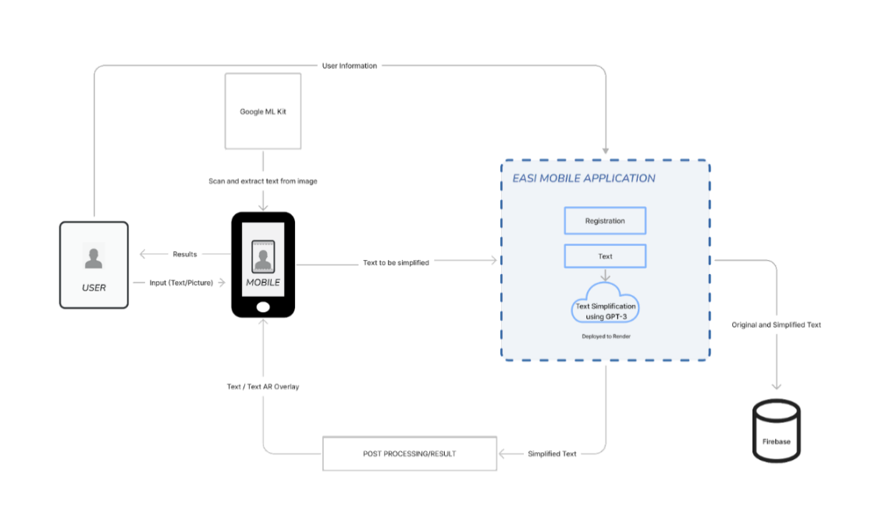

Figure 1. Software Architecture of the Proposed System

*Database Design*

The database design shows the independent tables which store data of the proposed system.

*Procedural design*

The procedural design specifies the steps that must be followed in order to operate equipment, complete a task, conduct a test, or maintain or install a system.

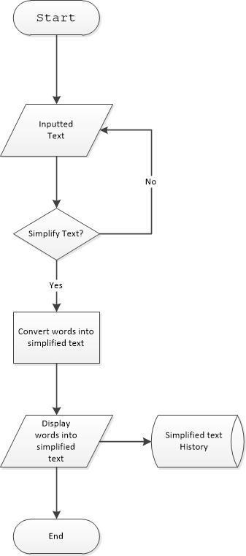

Figure 2.1. Process of Text Simplification

As shown in figure 2.1, this figure shows how the text simplification system works. The user inputs the text by typing it directly or by utilizing an OCR scanner. When the text is inserted and verified, the application will translate the text in its simplest form using GPT-3. The translated text will be displayed in the form of an AR overlay on top of the captured image or it will pop up below the typed text, depending on the mode of input. The simplified text will then be stored in the database.

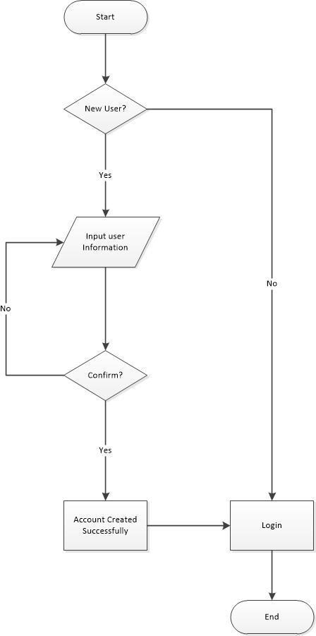

Figure 2.2. Account Creation

As shown in figure 2.2, this figure shows how to create accounts for new users. To create an account, the user is required to set an email and password. When the account is approved, the user can start to use the application. The user information will then be stored in the database.

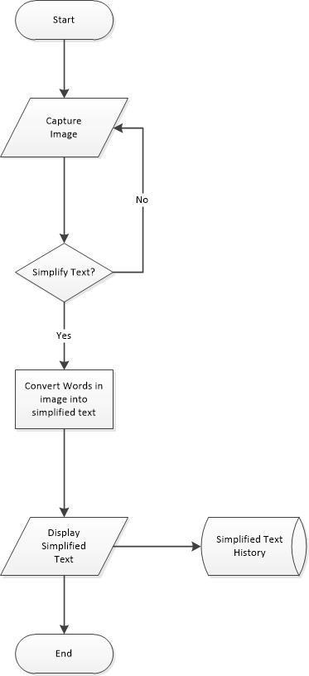

Figure 2.3. Image Input via Image Capture

As shown in figure 2.3, this figure shows how to input text using image capture. The user uses the OCR scanner to capture and scan text in the image. The application will start translating the captured text into its simplified form once the image text has been validated. The result will then be displayed on the screen and be directly stored in the database.

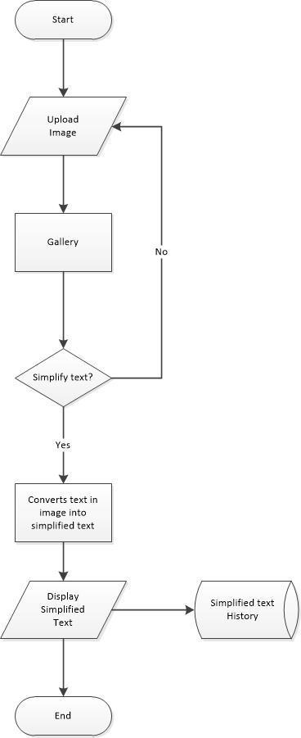

Figure 2.4. Image Input via Gallery

As shown in figure 2.4, the figure shows how to input and simplify text from the image gallery. The user uploads an image containing text – this image will be scanned by an OCR scanner to extract the text. The application will then simplify the extracted text using GPT-3. The simplified text result will be shown on the screen and will be stored in the database for retrieval.

*Object-Oriented Design*

The Object-Oriented Design shows the relationship and interaction between the classes and objects created in the proposed system.

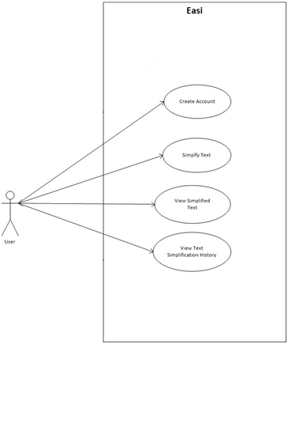

Figure 3. Use Case Diagram of the Proposed System

*System Development Life Cycle*

The Agile System Development Life Cycle emphasizes collaborative decision-making, customer satisfaction, and development across a series of short cycles or sprints. The crew works in various cycles, each of which lasts two to four weeks.

The Researchers chose the Agile Model because it is the most applicable SDLC approach to develop the proposed system. Through this model, researchers can work efficiently as it can help them to divide the work in each iteration and enables concurrent development. The Agile Model allows researchers to create changes or improvements dynamically. Before deployment of the proposed system, the researchers will go through a cycle or series of iterations for checking errors, quick responses to change and continuous development. As shown in the figure, the agile method was composed of the following stages:

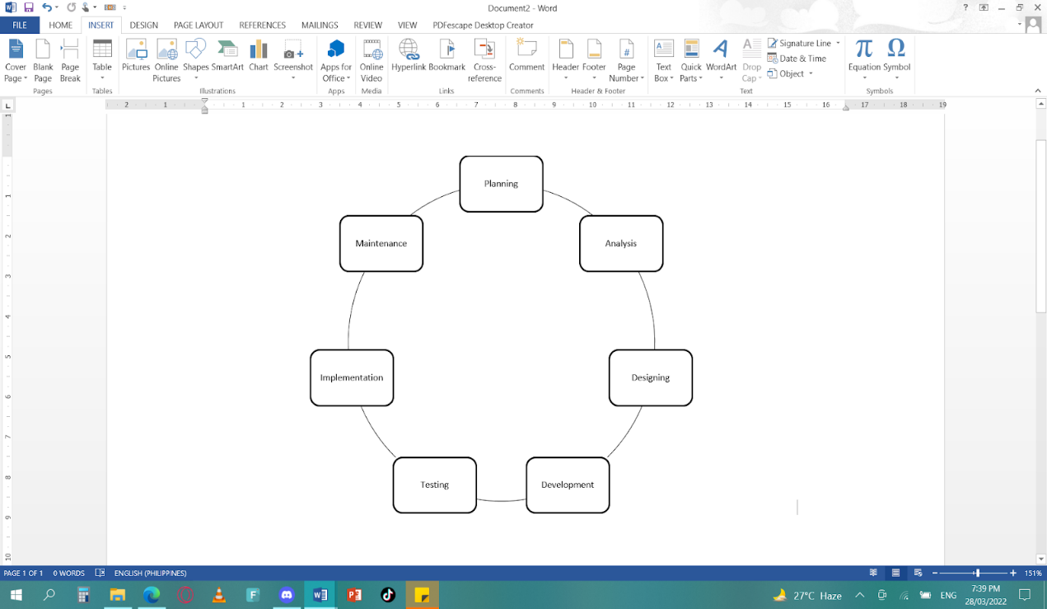

Figure 5. System Development Life Cycle Agile Method

Planning stage. In the planning stage, the researchers determine the project objectives in order to plan the predetermined course of action for the development of the proposed system. The researchers discuss the features addressing the goals of the proposed system and the scheduling of the task in each iteration.

Analysis. In the analysis stage, the researchers gather information and requirements in creating the proposed system. In this stage, the researchers analyze the potential requirements of the proposed system or analyze the costs of the GPT-3, hardware and software requirements, and the design of the proposed system.

Designing. In the analysis stage, this is where the researchers designed the requirements before developing the proposed system. The designer creates the prototype using Figma, the flow of the system, and the system architecture.

Development. In the development stage, the developers develop the system software using dart and python programming. Also, the developers use Google ML Kit OCR scanner and AR overlay to develop the proposed system. The frontend application will use Flutter application for the user interface.

Testing. In the testing stage, the researchers test the finished proposed system. The researchers check the proposed system if there are any errors in the systems. And in this stage, the researchers use the Accuracy test to ensure the effectiveness of the text simplification.

Implementation. In the implementation stage, the proposed system will be implemented to be used by users. It includes the installation software into mobile devices and user training. The researchers will train the teachers and students on how the proposed system works.

Maintenance. In the maintenance stage, the researchers conduct monthly maintenance of the proposed system. They will check if there are bugs and errors in the system. The researchers can also conduct a meeting at this stage if there are any problems and improvements in the proposed system.

CHAPTER 4 RESULTS AND DISCUSSION

Implementation

The text simplification application was developed to make English easier to understand for elementary students who are in grades four to six. It concerns both the modification of the vocabulary of the text (lexical simplification) and the modification of the structure of the sentences (syntactic simplification). Alongside, features such as OCR Scanner and AR Overlay will also be incorporated to be more user-friendly.

The mobile application was initially tested and deployed with the minimum requirements using an Oppo A74 5g which has a processor of Qualcomm SM4350 Snapdragon 480 5G, the operating system of Android 11, ColorOS 11.1, GPU of Adreno 619, and a CPU Octa-core (2x2.0 GHz Kryo 460 & 6x1.8 GHz Kryo 460). This was also the highest specifications that the application was able to work on.

Moreover, the mobile application is able to work with an internet connection through either Wi-Fi or data services as the application is online-dependent.

The development process was performed using Flutter API and Visual Studio Code as the IDE.  The implementation of the application’s database is synced in real-time with the use of the Firebase Database. Data can be ordered and questioned using the Firebase Realtime Database. In most cases, indexes are not needed during development because the database offers ad hoc querying for tiny data sets.

System Inputs and Outputs

The following figures are the foreseen user interface of the application. These interfaces will serve as the front-end design of the application. The screenshots are as follows:

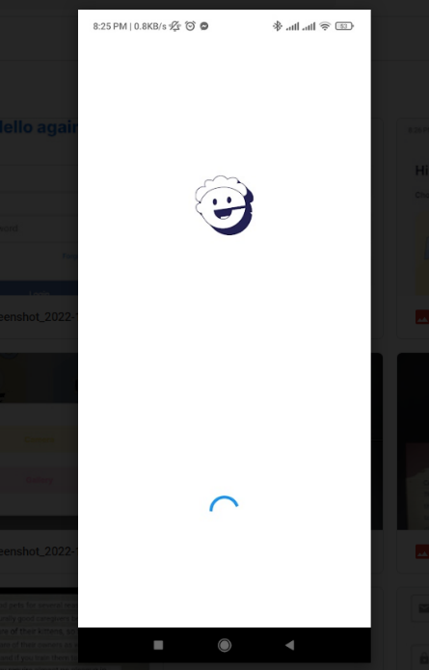

Figure 6 shows the splash screen. It is the introduction page that will be displayed to welcome users when launching the application. The splash screen flaunts the application’s name.

Figure 6. Splash Screen Interface

Figure 7 shows the login page interface. In this section, the user must input the previously agreed-upon username and password to access the application.

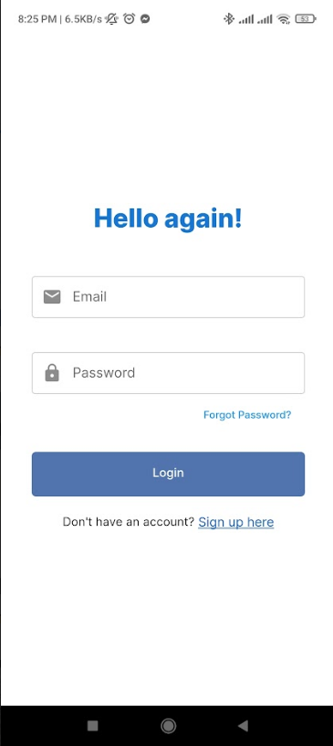

Figure 7. Login Screen Interface

Figure 8 shows the application’s sign-up page. In this section, users are required to input the necessary information in order to create an account to gain access to the application. The user needs to input his full name, and set a unique email address and password. The user can also use his Gmail account to register if he desires to.

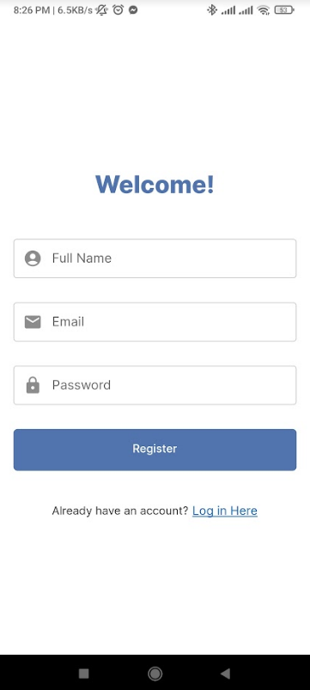

Figure 8. Sign-up Screen Interface

Figure 9 shows the home page of the system. It displays the application’s name at the top followed by he user’s name, mode of importing words, previously translated data, and icons indicating the home page and profile settings. You can see that the home icon has been given emphasis by its color.

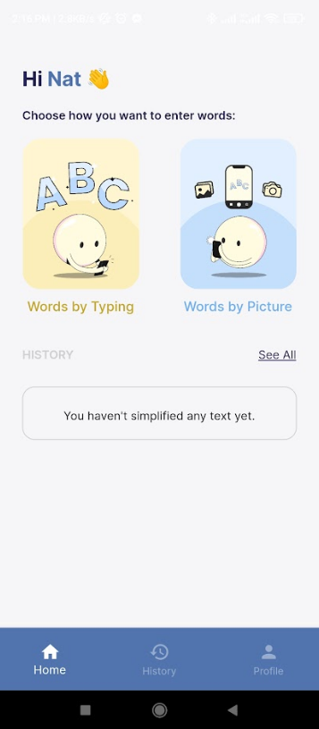

Figure 9. Home Screen Interface

Figure 10 displays the profile setting. The application’s name is also visible at the center top followed by the profile icon, user’s full name, and email address. You can also notice that the profile setting icon has given emphasis. The users can edit their current profile and create a new one on this page.

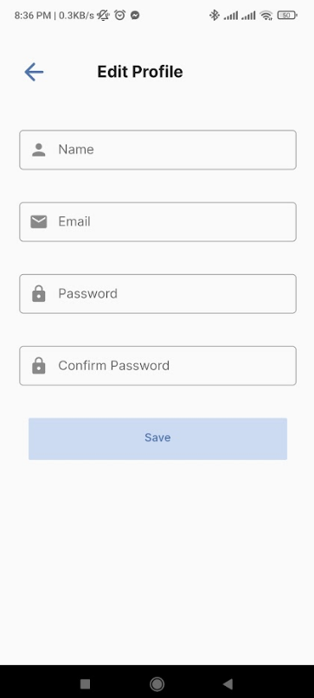

Figure 10. Profile Setting Screen Interface

Figure 11 shows one of the modes to input data which is by typing the text. The user can input the text on the first box and click the button “Make It Simple” below to start the process of text simplification. The translated text will then be displayed in the second box. There is a back button at the top left corner to allow the user to go back to the previous page.

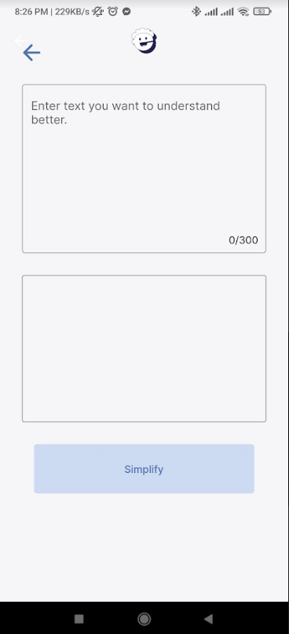

Figure 11. Interface for Inputting the Text to be translated

Figure 12 shows how to import text by capturing images. This application will use an OCR scanner to scan and recognize text from captured image documents.

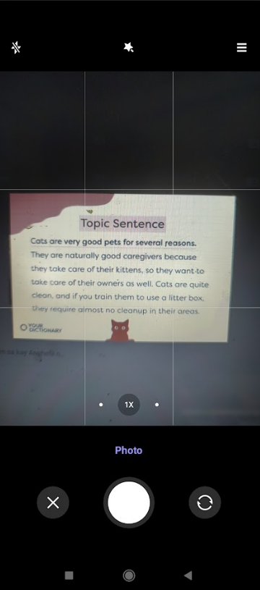

Figure 12. Capture Image to import text

Figure 13 demonstrates selecting and cropping specific parts of the captured image.  The user is given the opportunity to choose and crop parts in order to concentrate on the desired part of the captured text if they just want to translate a certain section of it.

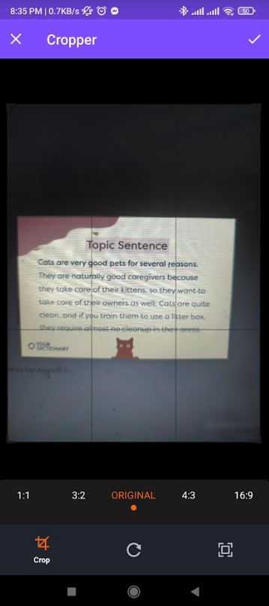

Figure 13. Crop Image

Figure 14 shows how the simplified text is displayed using AR overlay. When the user chooses to capture an image as a mode of importing text, the converted or translated text will then pop up in a form of an AR overlay on the top of the selected section of the captured text.

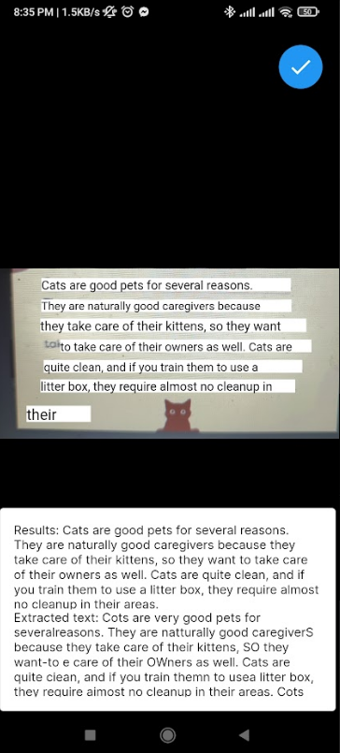

Figure 14. Display Translated Text Using AR Overlay

Results Interpretation and Analysis

In this study, the features of the application were evaluated using the Accuracy Test. The researchers collected 100 samples of different text statements to guarantee the accuracy of translation. Furthermore, to test the accuracy and efficiency of the OCR and AR overlay, they also gathered 100 samples of text-containing images for each.

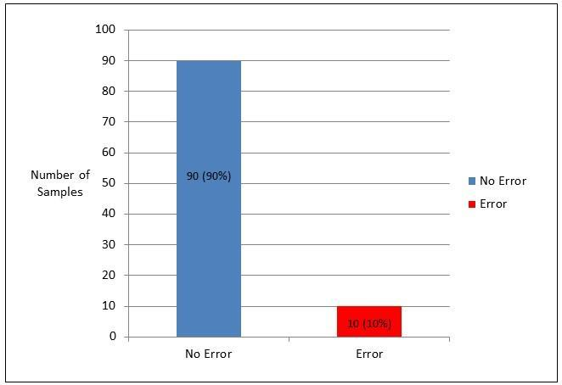

Figure 15. Text Simplification Accuracy Test Result

Text simplification was evaluated using the Accuracy test. 100 text samples were collected and tested to ensure the accuracy of the system in translating different sentences into their simplest terms. The figure shows that 90% of the text samples were accurately translated and 10% were not able to be simplified correctly. This indicates that the system exhibits effective performance in converting sentences and phrases into their simplest basic form.

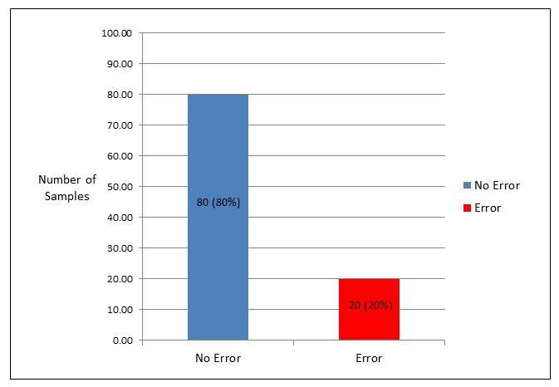

Figure 16. OCR Scanner Accuracy Test Result

The OCR Scanner feature was evaluated using the Accuracy test. 100 text image samples were collected and tested to ensure the accuracy of the application in extracting the text from images via camera or importing from the gallery. The figure shows 80% of the text image samples were accurately extracted and 20% were not accurately extracted. This concludes that the OCR Scanner feature has accurately extracted text from the sample inputted images.

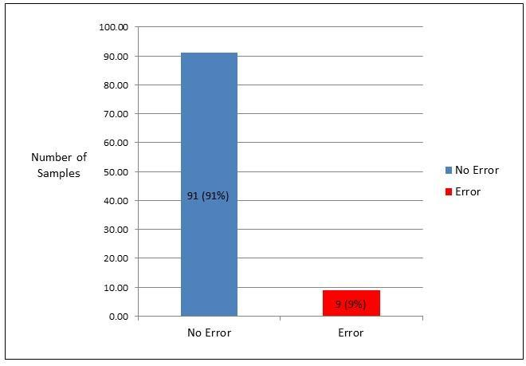

Figure 17. AR Overlay Accuracy Test Result

The AR Overlay feature was evaluated using the Accuracy test. 100 text image samples were collected and tested to ensure the accuracy of the application in displaying and overlaying the simplified text over the original text on the image. The figure shows 91% of the text image samples were accurately displayed and overlaid and 1% was not accurately displayed and overlaid. This concludes that the AR Overlay feature has accurately displayed and overlaid the simplified text onto the extracted image.

System Evaluation Results

The system evaluation was conducted to 13 elementary school teachers of Juan S. Jarencio Elementary School from Ilaya-Ivisan, Ivisan, Capiz. The researchers sent a letter to the principal and the data was collected through ISO 25010 evaluation form with the application attached.

Table 3

ISO 25010 - Functional Stability

|  |  |  |  |  |  |  |  |
| --- | --- | --- | --- | --- | --- | --- | --- |
| Indicators | | 5 | 4 | 3 | 2 | 1 | Mean |
| Completeness | The set of instructions all the specified task and user objectives. | 11 | 2 | 0 | 0 | 0 | 4.8 |
| Correctness | The system provides correct results with the needed degree of precision. | 10 | 3 | 0 | 0 | 0 | 4.8 |
| Appropriateness | The system provides the accomplishment of specified tasks and objectives. | 13 | 0 | 0 | 0 | 0 | 5.0 |

*Functional Stability.* The results shown in table 3 concluded that the system has an “Outstanding” functional stability with an overall mean of 4.9.  As well as, the “Completeness” with a mean of 4.8, “Correctness” with 4.8 mean, and “Appropriateness” with 5.0 mean. This indicates that the application is capable of providing functions that address the implied needs.

Table 4

ISO 25010 - Performance Efficiency

|  |  |  |  |  |  |  |  |
| --- | --- | --- | --- | --- | --- | --- | --- |
| Indicators | | 5 | 4 | 3 | 2 | 1 | Mean |
| Time behavior | The response and processing times and throughput rates of a product or system, when performing its functions, meet requirements. | 12 | 1 | 0 | 0 | 0 | 4.9 |
| Resource  Utilization | The amounts and types of resources used by a product or system, when performing its functions, meet requirements. | 13 | 0 | 0 | 0 | 0 | 5.0 |
| Capacity | The maximum limits of the product or system parameters meet requirements. | 12 | 1 | 0 | 0 | 0 | 4.9 |

*Performance Efficiency.* The results shown in table 4 concluded that the system has an “Outstanding” performance efficiency with an overall mean of 4.9.  As well as, the “Time behavior” with a mean of 4.9, “Resource Utilization” with 5.0 mean, and “Capacity” with 4.9 mean. This indicates that the application met the required performance

Table 5

ISO 25010 – Usability

|  |  |  |  |  |  |  |  |
| --- | --- | --- | --- | --- | --- | --- | --- |
| Indicators | | 5 | 4 | 3 | 2 | 1 | Mean |
| Appropriateness  Recognizability | Users can recognize whether a product or system is appropriate to their needs. | 13 | 0 | 0 | 0 | 0 | 5.0 |
| Learnability | A product or system enables the user to learn how to use it with effectiveness, efficiency in emergency situations. | 13 | 0 | 0 | 0 | 0 | 5.0 |
| Operability | A product or system is easy to operate, control and appropriate to use. Product or system is easy to operate, control and appropriate to use. | 13 | 0 | 0 | 0 | 0 | 5.0 |
| User error  protection | A product or system protects users against making errors. | 12 | 1 | 0 | 0 | 0 | 4.9 |
| Accessibility | A product or system can be used by people with the widest range of characteristics and capabilities to achieve a specified goal in a specified context of use. | 13 | 0 | 0 | 0 | 0 | 5.0 |

*Usability.* The results shown in table 5 concluded that the system has an “Outstanding” usability with an  overall mean of 4.98.  As well as, the “Appropriate Recognizability” with the mean of 5.0, “Learnability” with 5.0 mean, “Operability” of 5.0, “User error protection” with 4.9 mean, and “Accessibility” with 5.0 mean. This indicates that the application accomplished a specific goal in an effective, efficient, and satisfactory manner.

Table 6

ISO 25010- Reliability

|  |  |  |  |  |  |  |  |
| --- | --- | --- | --- | --- | --- | --- | --- |
| Indicators | | 5 | 4 | 3 | 2 | 1 | Mean |
| Maturity | The set of instructions all the specified task and user objectives. | 13 | 0 | 0 | 0 | 0 | 5.0 |
| Availability | A product or system is operational and accessible when required for use. | 13 | 0 | 0 | 0 | 0 | 5.0 |
| Recoverability | In the event of an interruption or a failure, a product or system can recover the data and establish the desired state of the system. | 13 | 0 | 0 | 0 | 0 | 5.0 |

*Reliability.* The results shown in table 6 concluded that the system has an “Outstanding” reliability with an overall mean of 5.0.  As well as, the “Maturity” with the mean of 5.0, “Availability” with 5.0 mean, and “Recoverability” of 5.0. This indicates that the application has the capability of performing well.

Table 7

ISO 25010 – Security

|  |  |  |  |  |  |  |  |
| --- | --- | --- | --- | --- | --- | --- | --- |
| Indicators | | 5 | 4 | 3 | 2 | 1 | Mean |
| Confidentiality | The prototype ensures that data are accessible only to those authorized to have access. | 13 | 0 | 0 | 0 | 0 | 5.0 |
| Integrity | A system, product or component prevents unauthorized access to, or modification of, computer programs or data. | 13 | 0 | 0 | 0 | 0 | 5.0 |
| Non-Repudiation | Actions or events can be proven to have taken place, so that the events or actions cannot be repudiated later. | 12 | 1 | 0 | 0 | 0 | 4.9 |
| Accountability | The actions of an entity can be traced uniquely to the entity. | 13 | 0 | 0 | 0 | 0 | 5.0 |
| Authenticity | The identity of a subject or resources can be proved to be the one claimed. | 13 | 0 | 0 | 0 | 0 | 5.0 |

*Security.* The results shown in table 7 concluded that the application has an “Outstanding” reliability with an overall mean of 4.98.  As well as, the “Confidentiality” with the mean of 5.0, “Integrity” with 5.0 mean, “Non-Repudiation” of 4.9, “Accountability” with 5.0 mean, and “Authenticity” with 5.0 mean. This indicates that the application has the capability of protecting information and from data security breaches or vulnerabilities.

Table 8

Summary of ISO 25010

|  |  |  |
| --- | --- | --- |
| ISO 25010 | Overall Mean | Interpretation |
| Functional Stability | 4.9 | Outstanding |
| Performance Stability | 4.9 | Outstanding |
| Usability | 4.98 | Outstanding |
| Reliability | 5.0 | Outstanding |
| Security | 4.98 | Outstanding |

Legend:

    Scales of Mean     Description

5 - 4.1 Outstanding

4 – 3.1 Very Satisfactory

3 – 2.1 Satisfactory

2 – 1.1 Fair

  1 Poor

The results shown in table 8 indicate that the text simplification application has attained an overall “Outstanding” rating based on the ISO 25010 standard with an overall mean of 4.95. Furthermore, among the five quality requirements, Reliability has the highest mean value of a perfect 5.0 which is equivalent to an “Outstanding” rating. The remaining quality requirements which are functional stability, performance efficiency, usability, and security have also attained an “Outstanding” rating.

Results have met the quality evaluation criteria and thus attest to the application’s suitability for meeting implied needs of its users.

CHAPTER 5 SUMMARY, CONCLUSIONS, IMPLICATIONS AND RECOMMENDATIONS

Summary of the Proposed Study Design and Implementation

This study developed Easi, a mobile-based text simplification application that utilizes Natural Language Processing. It focuses on translating difficult terms into a simple structure based on the Plain (English) Language standards in order for students in grades 4-6 to easily understand the idea or the meaning of the text. Through this application, they would be able to improve their reading comprehension.

The user can create an account and the application will store the user’s information, specifically the user’s name, email address, and password. The user can convert difficult sentences or phrases by putting text either through manual typing or taking pictures. If the user used the digital image, the application will extract the text from the picture taken. The simplified version of the extracted text will then be displayed as an AR overlay. The application is only limited to Android devices and it requires internet connection for it to effectively translate inputted text or extracted text from pictures with the help of GPT-3 as well as Google ML Kits’ OCR Scanner and Python (Flask). Moreover, the application will store the history of the user's original text input or extracted text from the image and its simplified version.

  The development process was performed using Flutter API and Visual Studio Code as the IDE.  The implementation of the application’s database is synced in real-time with the use of the Firebase Database. Data can be ordered and questioned using the Firebase Realtime Database. In most cases, indexes are not needed during development because the database offers ad hoc querying for tiny data sets. It was then tested and deployed with the minimum requirements using an Oppo A74 5g which has a processor of Qualcomm SM4350 Snapdragon 480 5G, the operating system of Android 11, ColorOS 11.1, GPU of Adreno 619, and a CPU Octa-core (2x2.0 GHz Kryo 460 & 6x1.8 GHz Kryo 460). This is the highest specification that the application was able to work on.

  This study will be a great help for students that are having a hard time understanding difficult terms or sentences in English. Text simplification is a helpful tool to convert texts into the simplest form in order to easily comprehend the idea of the information. Through this application, the students’ reading comprehension will improve.  Moreover, this is also beneficial for teachers as they are responsible for educating the students. They can utilize it as a tool in creating effective learning materials that are suited for their students’ learning capabilities and development.

Summary of Findings

The text simplification mobile application was developed to make English easier to understand for elementary students who are in grades four to six using Natural Language Processing through GPT-3. Apart from text simplification, the application utilizes technology such as OCR Scanner and an AR Overlay as a method of extracting and displaying text through image.

The application is still subject to improvements that will further improve its capabilities in the future. This includes its ability to simplify, extract, and display text based on the results of the conducted Accuracy Tests. The application simplifies text best if the inputted text is below 200 words and does not contain any scientific terms or jargon specific to a certain field such as Medicine, Law, etc, or the inputted text is not a narrative/story. Moreover, the application will not simplify text that it has already deemed simple and will only change those that are not.  The OCR feature works best when the image is uploaded through the gallery rather than taken through the device’s camera and if it is clear and bright/under a bright environment. It however confuses certain letters such as “I” and “l” and punctuations “,” and “.” depending on the font of the text. The AR Overlay feature works best if the results/simplified text is shorter than the prompt/inputted text. After evaluating the application, the results were examined and showed an outstanding rating from the evaluators of the application.

Conclusions

After the implementation and testing, the results of the proposed application were obtained and have met its objectives as follows:

1. The text simplification application that uses Natural Language Processing with the help of GPT3 performed well. It has met the required qualities and its objectives which are to simplify text, extract text and display results.
2. The accuracy test regarding text simplification has shown that out of 100 sample texts, 90% were accurately simplified. In addition, the OCR feature obtained 80% accuracy and the AR overlay feature obtained 91% accuracy. Thus, this indicates that these features satisfy the requirements needed and can perform their purpose.
3. The ISO 25010 evaluation results showed that the application had an overall outstanding rating with an overall mean of 4.95. Thus, states the application’s suitability for meeting the needs of the users.

Recommendations

The following recommendations are suggested based on the observations and conclusions presented:

1. To include pop-up stickers in the application when the user has done a task on Easi.
2. To include mini-games in the application for the motivation to learn English and improve vocabulary using Easi.
3. To include emphasis lines with colors on the noun, verb, adverb, adjective and conjunction of the extracted text.
4. To include more language options that can be extracted into simple English using the application.
5. To add a delete button on the history settings to filter and sort the results of the Text simplification.
6. To add a share option on the result for which the users can share it with others.
7. For a stand-alone web system, students can access or use the application when they are on their desktops or laptops.
8. To make the application available on IOS devices.
9. To conduct A/B testing to determine if the translated text has a significant impact to the reading comprehension of the students.

References

Alarcon, R., Moreno, L., & Martine, P. (2021). Lexical  Simplification System to Improve Web Accessibility. Retrieved March 29, 2022 from https://ieeexplore.ieee.org/document/9400837.

AlleyDog.com (n.d) (1998-2023). Retrieved January 15, 2023, from https://www.alleydog.com/glossary/definition.php?term=Accuracy+Test#:~:

Balinbin, A. (2020, December 2). Filipino students falling behind      in reading, writing levels in Southeast Asia. BusinessWorld Online. Retrieved June 4, 2022, from https://www.bworldonline.com/editors-picks/2020/12/03/331914/filipino-students-falling-behind-in-reading-writing-levels-in-southeast-asia/

Bergin, J.  (2020). Simplify Text. Retrieved April 5, 2022 from https://www.atandme.com/?p=3440&fbclid=IwAR2w6J7s9JN62b41kv5agsAkbexXZt2ttNkOtOO4VnlIDr3xhDJ9svZxQFA.

Clements, J. (2020). What is reading comprehension and why is it important? Oxfordowl. Retrieved June 1, 2022, from https://www.oxfordowl.co.uk/welcome-back/for-school-back/pathways-page/pathwayslist/teaching-comprehension/background-questions-tc/wales--16/what-is-reading-comprehension-and-why-is-it-important--2

Collins Dictionary (n.d). User. Retrieved from https://www.collinsdictionary.com/dictionary/english/user

Coursera (2022). What Is Python Used For? A Beginner’s Guide. Retrieved from https://www.coursera.org/articles/what-is-python-used-for-a-beginners-guide-to-using-python

Crossley, S. (2020). NATURAL LANGUAGE PROCESSING IN EDUCATION. Retrieved March 27, 2022 from https://www.the-learning-agency-lab.com/the-learning-curve/how-npl-will-change-education/

Das et al. (2021). A Hybrid Sequential Model for Text Simplification. Retrieved from https://www.researchgate.net/publication/348624598_A_Hybrid_Sequential_Model_for_Text_Simplification

Decena, A. (2021). Survey on the Reading Difficulties of K-12 Learners in Selected Tagalog Speaking Provinces: Basis for Intervention.  Retrieved June 2, 2022 from https://www.ijase.org/index.php/ijase/article/view/61/41

Dong et al. (2019). EditNTS: An Neural Programmer-Interpreter Model for Sentence Simplification through Explicit Editing. Retrieved from https://aclanthology.org/P19-1331.pdf

Ermakova et al. (2021). Text Simplification for Scientific Information Access: CLEF 2021 SimpleText Workshop. Retrieved March 29, 2022 from https://hal.archives-ouvertes.fr/hal-03121986/document

Hayes, A. (2020). Augmented Reality (AR) Defined, with Examples and Uses. Retrieved from https://www.investopedia.com/terms/a/augmented-reality.asp#:~:text=Augmented%20reality%20(AR)%20involves%20overlaying,and%20collect%20unique%20user%20data

IBM Cloud Education (2020). Unsupervised Learning. Retrieved April 6, 2022 from https://www.ibm.com/cloud/learn/unsupervised-learning

Kauchak, D & Leroy, G. (2020). A Web-Based Medical Text Simplification Tool. Retrieved March 29, 2022 from https://scholarspace.manoa.hawaii.edu/bitstream/10125/64200/0371.pdf

Litman, D. (2016). Natural Language Processing for Enhancing Teaching and Learning. Retrieved March 27, 2022 from https://www.aaai.org/ocs/index.php/AAAI/AAAI16/paper/viewFile/12310/12208

Loton, T., & Loton, T. (2019, October 15). Render Review 2023 – Is It Worth It? Website Planet. Retrieved January 16, 2023, from https://www.websiteplanet.com/web-hosting/render/

Lutkevich, B. (2021). Natural language processing (NLP). Retrieved from https://www.techtarget.com/searchenterpriseai/definition/natural-language-processing-NLP#:~:text=Natural%20language%20processing%20(NLP)%20is,in%20the%20field%20of%20linguistics

Magsambol B. (2019). PH lowest among 58 countries in math, science – global assessment. Retrieved from https://www.rappler.com/nation/filipino-students-lagging-behind-math-science-timms-international-results-2019/

Mariñas, J. (2021, July 28). 3 Reasons Why The Philippines is One of the Top English-Proficient Countries for Business. Cloudemployee.Co.Uk. Retrieved June 4, 2022, from https://cloudemployee.co.uk/blog/it-outsourcing/why-philippines-for-business

Markowitz, D. (2021). Transformers, Explained: Understand the Model Behind GPT-3, BERT, and T5. Retrieved March 15, 2022 from https://daleonai.com/transformers-explained

Marr, B. (2020). What Is GPT-3 And Why Is It Revolutionizing Artificial Intelligence? Retrieved from https://www.forbes.com/sites/bernardmarr/2020/10/05/what-is-gpt-3-and-why-is-it-revolutionizing-artificial-intelligence/?sh=1b72403d481a

Morales et at., (2019). Effectiveness of Rewordify in a Receptive Skill: Implication in Reading Comprehension in EFL A2 Ecuadorian Learners in Tertiary Education Level. Retrieved March 29, 2022 from https://eric.ed.gov/?id=EJ1267624&fbclid=IwAR3jbWub76Oq2taqr5cSWa5xG-bH7tod9Y1U7tBuPomtSqHck-YYQa-mcpY

Mother Tongue-Based Multilingual Education in the Philippines: Its success and struggle. (2021, March 20). De Educatione Meridie. Retrieved June 4, 2022, from https://varlyproject.blog/mother-tongue-based-multilingual-education-in-the-philippines-its-success-and-struggle/

NECC (2022). What is OCR. Retrieved January 12, 2022 from https://www.necc.mass.edu/wp-content/uploads/accessible-media-necc/uncategorized/resources/What-is-OCR.pdf

Nordquist, N. (2018, March 13). What Is Plain English? ThoughtCo. Retrieved June 4, 2022, from https://www.thoughtco.com/plain-english-language-1691513

Omelianchuk, K., Raheja, V., & Skurzhanskyi, O. (2021). Text Simplification by Tagging. Retrieved March 29, 2022 from https://arxiv.org/abs/2103.05070

Paperswithcode (n.d). Text Simplification. Retrieved from https://paperswithcode.com/task/text-simplification

Plain Language (2022). Plain language guidelines. Retrieved April 4, 2022 from <https://www.plainlanguage.gov/guidelines/>

Plain Language (2022). What is plain language. Retrieved April 4, 2022 from https://www.plainlanguage.gov/about/definitions/#:~:text=The%20Plain%20Writing%20Act%20of,not%20be%20plain%20to%20others

Quiang et al., (2020). Lexical Simplification with Pre-Trained Encoders. Retrieved March 29, 2022 from https://arxiv.org/pdf/1907.06226.pdf

Reysio-Cruz, M. (2019). Worst PH ranking in math, science, reading prompts DepEd review. Retrieved from https://newsinfo.inquirer.net/1198208/worst-ph-ranking-in-math-science-reading-prompts-deped-review

Ropero, G. (2019). Why Pinoy students ranked last in reading comprehension survey. Retrieved from https://news.abs-cbn.com/news/12/05/19/why-pinoy-students-ranked-last-in-reading-comprehension-survey

Ruder, S. (2022). NLP-progress (Version 1.0.0) [Computer software]. Retrieved March 11, 2022 from https://doi.org/10.5281/zenodo.1234

Rutzler, S. (2020, December 14). Importance of Reading Comprehension. Math Genie. Retrieved June 1, 2022, from https://www.mathgenie.com/blog/importance-of-reading-comprehension#:%7E:text=Having%20excellent%20reading%20comprehension%20skills,in%20a%20person’s%20personal%20life.

Saavedra, J. R. (2019, July 29). PH emerging as world’s “Study English” powerhouse: DOT exec. Philippine News Agency. Retrieved June 4, 2022, from https://www.pna.gov.ph/articles/1076349

Saggion, H. (2017). Automatic Text Simplification. Retrieved March 29, 2022 from Automatic Text Simplification (aclanthology.org)

Saggion, H. (2018). Text Simplification. Retrieved March 27, 2022 from https://www.oxfordhandbooks.com/view/10.1093/oxfordhb/9780199573691.001.0001/oxfordhb-9780199573691-e-52

Schmelzer, R. (2021). GPT-3. Retrieved April 5, 2022 from https://www.techtarget.com/searchenterpriseai/definition/GPT-3#:~:text=GPT%2D3%2C%20or%20the%20third,and%20sophisticated%20machine%2Dgenerated%20text

Sheang, K. C., & Saggion, H. (2021). Controllable Sentence Simplification with a Unified Text-to-Text transfer transformer. Retrieved March 29, 2022 from https://aclanthology.org/2021.inlg-1.38.pdf

Spacey, J. (2023). 9 Examples of Natural Language Processing. Retrieved from https://simplicable.com/IT/natural-language-processing

Terry, B. (2022, January 20). Vocabulary and Reading Comprehension –. Scholar Within. Retrieved June 4, 2022, from https://scholarwithin.com/vocabulary-and-reading-comprehension

Thomas, G. (2019). What is Flutter and Why You Should Learn it in 2020. Retrieved from https://www.freecodecamp.org/news/what-is-flutter-and-why-you-should-learn-it-in-2020/#:~:text=Flutter%20is%20a%20free%20and,(for%20iOS%20and%20Android)

Tomas, M., Villaros, E. and Galman, S. (2021). The Perceived Challenges in Reading of Learners: Basis for School Reading Programs. Open Journal of Social Sciences, 9, 107-122. doi: 10.4236/jss.2021.95009.

Tyson, M. (2022). What is an API? Application programming interfaces explained. Retrieved from https://www.infoworld.com/article/3269878/what-is-an-api-application-programming-interfaces-explained.html

UNICEF & SEAMEO. (2020). SEA-PLM 2019 Main Regional Report, Children's learning in 6 Southeast Asian countries. Bangkok, Thailand: United Nations Children's Fund (UNICEF & Southeast Asian Ministers of Education Organization (SEAMEO) – SEA-PLM Secretariat.

US Food and Drug Administration (2018). The Plain Writing Act of 2010. Retrieved January 4, 2022 from https://www.fda.gov/about-fda/plain-writing-its-law/plain-writing-act-2010

Van et al. (2020). AutoMeTS: The Autocomplete for Medical Text Simplification. Retrieved March 29, 2022 from https://arxiv.org/abs/2010.10573

Vu et al., (2018). Sentence Simplification with Memory-Augmented Neural Networks. Retrieved   March 29, 2022 from Sentence Simplification with Memory-Augmented Neural Networks - ACL Anthology

Woodford, C. (2021). Optical character recognition (OCR). Retrieved from https://www.explainthatstuff.com/how-ocr-works.html

Appendices

Appendix A

Letter to the Adviser

February 4, 2022

**CYRENEO S. DOFITAS JR.**

Associate Professor I

West Visayas State University

Luna St. Lapaz, Iloilo City

Dear Prof. Cyreneo S. Dofitas Jr.,

The undersigned are BS Information Technology Research 1/Thesis 1 students of CICT, this university. Our thesis/capstone project title is “Easi: A Text Simplification Mobile Application Using Natural Language Processing”.

Knowing of your expertise in research and on the subject matter, we would like to request you to be our **Thesis Adviser.**

We are positively hoping for your acceptance. Kindly check the corresponding box and affix your signature in the space provided. Thank you very much.

Respectfully yours,

1. Anghela A. Abastillas
2. Nathalie Elgaran
3. Cressida Jane D. Espino
4. Zenrick G. Parcon
5. Abigail Kaye R. Unating

PS:

*Advisers are tasked to work with the students in providing direction assistance as needed in their thesis/capstone project. They shall meet with the students weekly or as needed to provide direction, check on progress and assist in resolving problems until such a time that the students pass their defenses and submit their final requirements, as well as, preparing their evaluations and grades.*

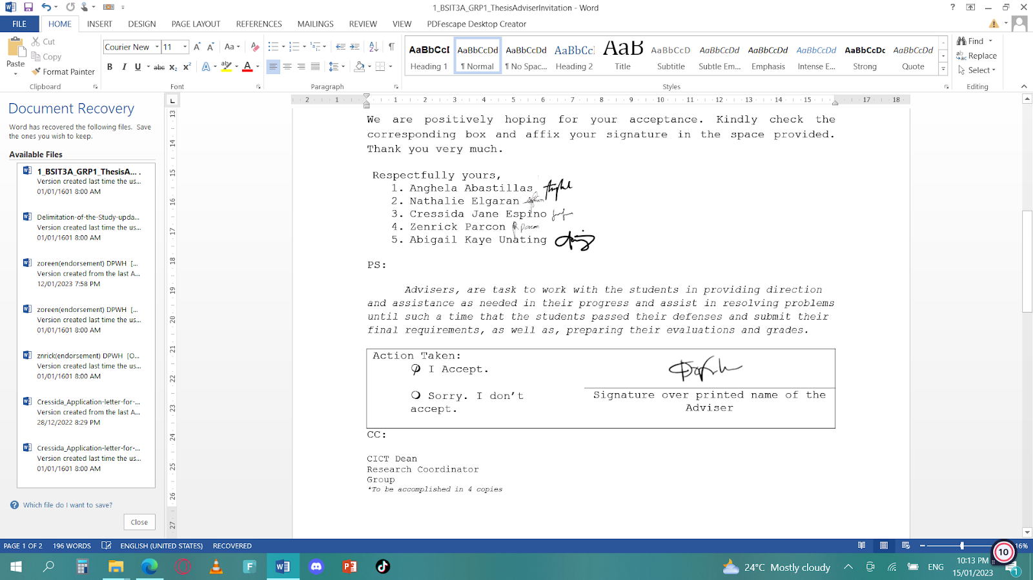

CC:

CICT Dean

Research Coordinator

Group

*\*To be accomplished in 4 copies*

Appendix B

Letter to the Co-Adviser

February 4, 2022

**KEITH CENSORO**

iT Instructor

West Visayas State University

Luna St. Lapaz, Iloilo City

Dear Prof. Keith Censoro.,

The undersigned are BS Information Technology Research 1/Thesis 1 students of CICT, this university. Our thesis/capstone project title is “Easi: A Text Simplification Mobile Application Using Natural Language Processing”.

Knowing of your expertise in research and on the subject matter, we would like to request you to be our **Co-Thesis Adviser.**

We are positively hoping for your acceptance. Kindly check the corresponding box and affix your signature in the space provided. Thank you very much.

Respectfully yours,

1. Anghela A. Abastillas
2. Nathalie Elgaran
3. Cressida Jane D. Espino
4. Zenrick G. Parcon
5. Abigail Kaye R. Unating

PS:

*Advisers are tasked to work with the students in providing direction assistance as needed in their thesis/capstone project. They shall meet with the students weekly or as needed to provide direction, check on progress and assist in resolving problems until such a time that the students pass their defenses and submit their final requirements, as well as, preparing their evaluations and grade*



CC:

CICT Dean

Research Coordinator

Group

*\*To be accomplished in 4 copies*

Appendix C

Letter to the ISO Evaluators

November 8, 2022

**BASA, MARY JEARN U.**

Principal 1

Don Juan S. Jarencio Memorial School

Brgy, Ilaya-Ivisan, Ivisan Capiz

Dear Mrs. Basa,

Good day!

We, the researchers from the College of Information and Communication Technology of the West Visayas State University, are writing this letter to formally inquire about the availability of the teachers of the Don Juan S. Jarencio Memorial School as our evaluators for our research study entitled, “Easi: A Text Simplification Mobile Application Using Natural Language Processing”.

We are anticipating for your most positive response to help in answering our survey through Google Forms for the improvement of our proposed research study.

We are hoping for your favorable response. Thank you very much for your continued support.

Researchers:

Anghela A. Abastillas

Nathalie Elgaran

Cressida Jane D. Espino

Zenrick G. Parcon

Abigail Kaye R. Unating



Research Adviser:

**CYRENEO S. DOFITAS JR.**

Appendix D

Letter to the Grammarian

February 4, 2022

**NAME**

Position

West Visayas State University

Luna St. Lapaz, Iloilo City

Dear Prof.,

The undersigned are BS Information Technology Research 1/Thesis 1 students of CICT, this university. Our thesis/capstone project title is “Easi: A Text Simplification Mobile Application Using Natural Language Processing”.

In line with this, we would like to request you to be our **Thesis Grammarian**. We believe that your expertise in this area will significantly improve our study.

We are positively hoping for your acceptance. Kindly check the corresponding box and affix your signature in the space provided. Thank you very much.

Respectfully yours,

1. Anghela A. Abastillas

2. Nathalie Elgaran

3. Cressida Jane D. Espino

4. Zenrick G. Parcon

5. Abigail Kaye R. Unating

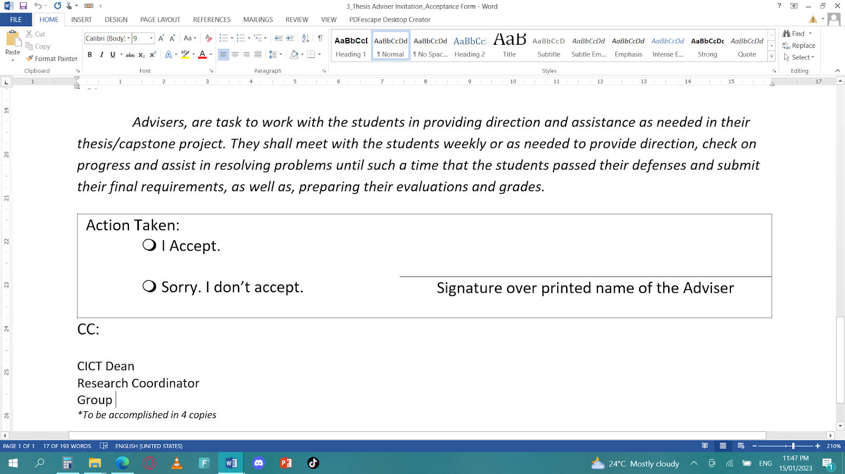

Appendix E

Gantt Chart

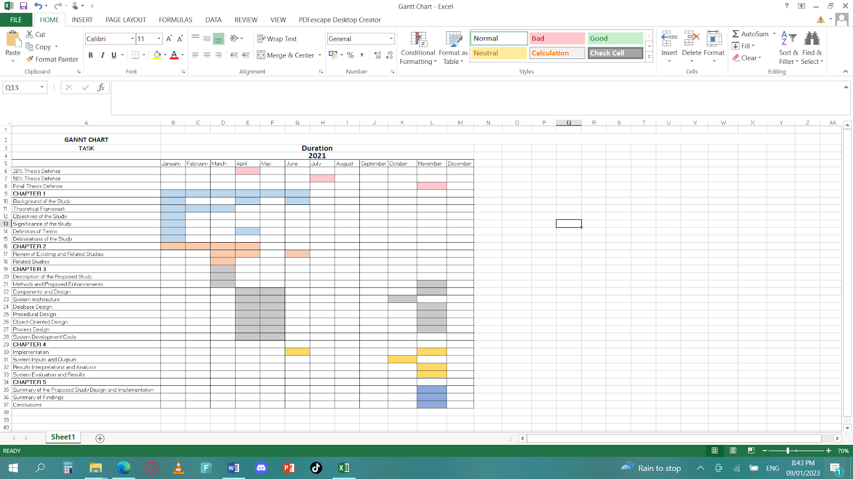

Appendix F

Data Dictionary

|  |  |  |  |  |  |
| --- | --- | --- | --- | --- | --- |
| Register | | | | | |
| **Field Name** | **Data Type** | **Field Length** | **Constraint** | **Description** | **Required** |
| userUID | varchar | 50 | Primary Key | User id, Auto Generated | Yes |
| fullname | string | 50 | Not null | User first name | Yes |
| email | string | 50 | Foreign Key | User email | Yes |
| password | string | 50 | Foreign Key | User Password | Yes |

|  |  |  |  |  |  |
| --- | --- | --- | --- | --- | --- |
| Login | | | | | |
| **Field Name** | **Data Type** | **Field Length** | **Constraint** | **Description** | **Required** |
| email | string | 50 | Primary Key | User email | Yes |
| password | string | 50 | Primary Key | User Password | Yes |

|  |  |  |  |  |  |
| --- | --- | --- | --- | --- | --- |
| User | | | | | |
| **Field Name** | **Data Type** | **Field Length** | **Constraint** | **Description** | **Required** |
| userUID | varchar | 50 | Primary Key, Foreign Key | User id, Auto Generated | Yes |
| email | string | 50 | Primary Key | User email | Yes |
| stext | varchar | 50 | Not null | User simplified text | Yes |

|  |  |  |  |  |  |
| --- | --- | --- | --- | --- | --- |
| texthistory | | | | | |
| **Field Name** | **Data Type** | **Field Length** | **Constraint** | **Description** | **Required** |
| userUID | varchar | 50 | Primary Key, Foreign Key | User id, Auto Generated | Yes |
| date | var | 50 | Not null | User date | Yes |
| prompt | string | 50 | Not Null | User prompt text | Yes |
| result | string | 50 | Not Null | User simplified text result | Yes |

Appendix G

Entity Relationship Diagram

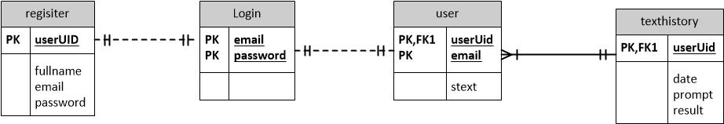

Appendix H

Source Code

import 'package:easi/history_ui.dart';

import 'package:easi/navigation.dart';

import 'package:easi/screens/registration_screen.dart';

import 'package:easi/wrapper.dart';

import 'package:flutter/material.dart';

import 'package:flutter/services.dart';

import 'package:internet_connection_checker/internet_connection_checker.dart';

import 'package:provider/provider.dart';

import 'package:firebase_core/firebase_core.dart';

import 'package:splashscreen/splashscreen.dart';

import 'internet_not_available.dart';

import 'profile.dart';

import 'package:easi/screens/login_screen.dart';

import 'auth_service.dart';

// void main() => runApp(MyApp());

void main() async {

  // Transparent status bar

  WidgetsFlutterBinding.ensureInitialized();

  await Firebase.initializeApp();

  SystemChrome.setSystemUIOverlayStyle(SystemUiOverlayStyle(

    statusBarColor: Colors.transparent,

  ));

  // SystemChrome.setEnabledSystemUIMode(SystemUiMode.immersiveSticky);

  runApp(MyApp());

}

class MyApp extends StatelessWidget {

  // This widget is the root of your application.

  @override

  Widget build(BuildContext context) {

    return StreamProvider<InternetConnectionStatus>(

      initialData: InternetConnectionStatus.connected,

      create: (_) {

        return InternetConnectionChecker().onStatusChange;

      },

      child: MultiProvider(

        providers: [Provider<AuthService>(create: (_) => AuthService())],

        child: MaterialApp(

          debugShowCheckedModeBanner: false,

          title: 'Flutter Demo',

          theme: ThemeData(

              primarySwatch: Colors.blue,

              fontFamily: 'Inter',

              scaffoldBackgroundColor: Color(0xFFF6F6F8)),

          home: SplashScreen(

            useLoader: true,

            seconds: 4,

            navigateAfterSeconds: MyHomePage(),

            photoSize: 40,

            image: Image.asset(

              'assets/logo.png',

              height: 200,

              width: 200,

            ),

            backgroundColor: Colors.white,

          ),

          // initialRoute: '/',

          // routes: {

          //   '/': (context) => Wrapper(),

          //   '/login': (context) => LoginScreen(),

          //   '/register': (context) => RegistrationScreen(),

          //   '/profile': (context) => Profile(

          //         userKey: '',

          //       ),

          //   '/history': (context) => HistoryUI(),

          // },

        ),

      )

    );

  }

}

class MyHomePage extends StatefulWidget {

  @override

  _MyHomePageState createState() => _MyHomePageState();

}

class _MyHomePageState extends State<MyHomePage> {

  @override

  void initState() {

    super.initState();

  }

  // Bottom navigation screen options

  @override

  Widget build(BuildContext context) {

    return Stack(

      children: [

         Provider.of<InternetConnectionStatus>(context) ==

                    InternetConnectionStatus.disconnected ? Visibility(

          visible: Provider.of<InternetConnectionStatus>(context) ==

              InternetConnectionStatus.disconnected,

          child: const InternetNotAvailable(),

        ) : Wrapper()

      ],

    );

  }

}

Appendix I

ISO Questionnaire

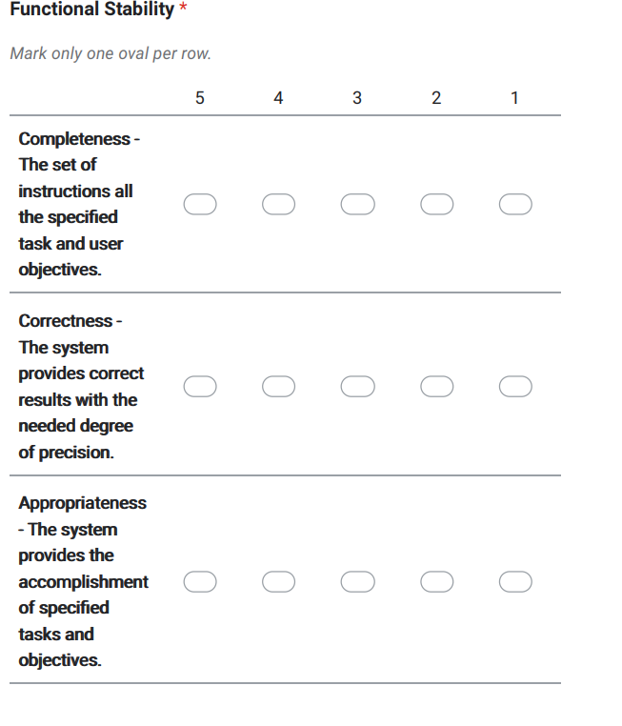

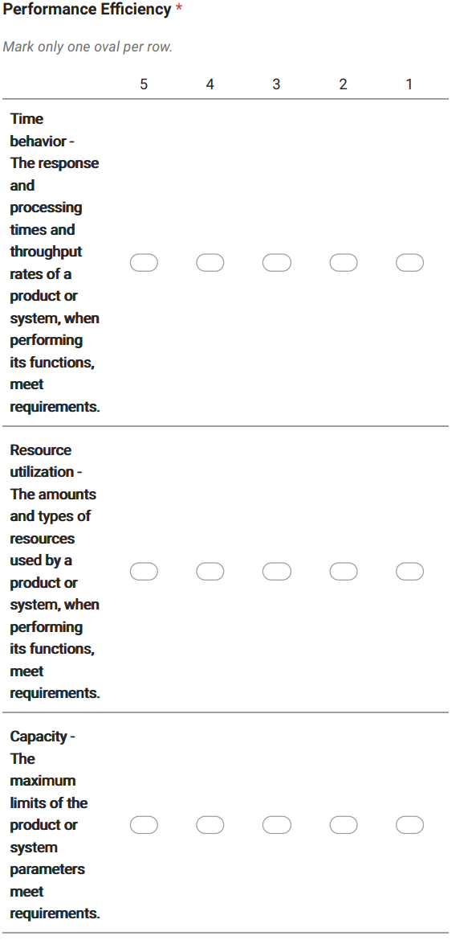

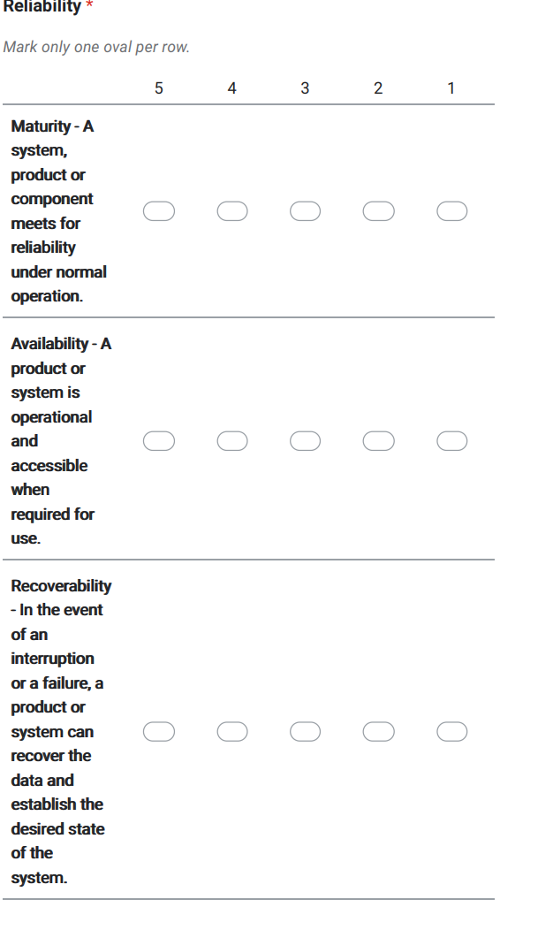

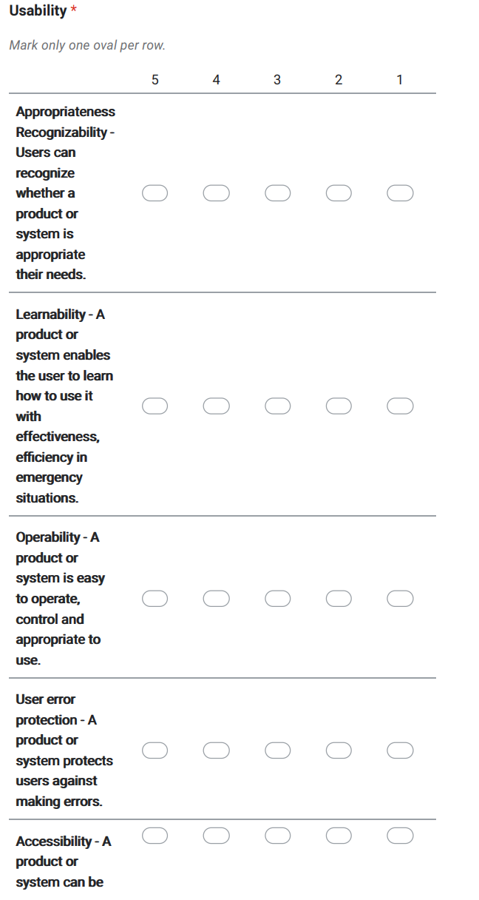

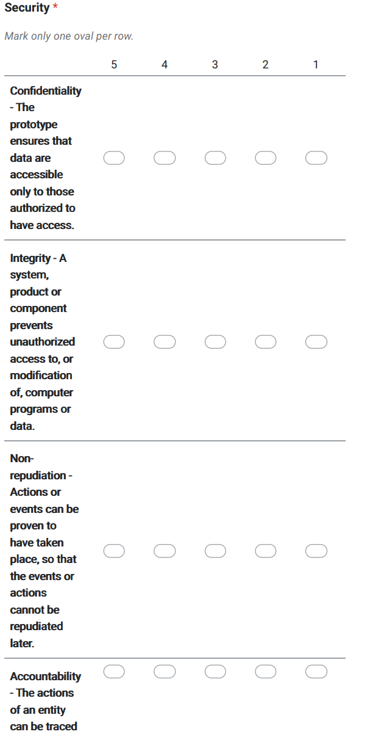

Appendix J

Disclaimer

This software project and its corresponding documentation titled “EASI: A Text Simplification Mobile Application Using Natural Language Processing” is submitted to the College of Information and Communication Technology, West Visayas State University and Community, in partial fulfillment of the requirements for the degree, Bachelor of Science in Information Technology. It is the product of our own work, except where indicated text.

We, hereby grant the College of Information and Communications Technology permission to freely use, publish in local or international journals/conferences, reproduce, or distribute publicly the paper and electronic copies of this software project and its corresponding document in whole or in part, provided that we are acknowledged.

Anghela A. Abastillas

Nathalie M. Elgaran

Cressida Jane D. Espino

Zenrick G. Parcon

Abigail Kaye R. Unating

JANUARY 2023